|  |
| --- |
| **Tars Post Services** |



|  |
| --- |
| **Purpose:** This Documentation acts as the main support document for Application Services and Operations front line staff. The OPM will include anything that is repeatable.  **Important Note:** Once project documentation has been handed over and signed off by both parties, any further revisions will be the responsibility of Operations and / or Application Services |
|  |

|  |  |
| --- | --- |
| **Group Members** | |
| **Student ID** | **Student Names** |
| Student | Hafiz Muhammad Muzzamil Jamal |
| Student | Nimra Ahsan |
| Student | Areej Kamran |
| Student | Muhammad Muddassir Mihilar |
|  | |
| **Batch** | 1910b2 |
| **Faculty** | Ms. Samreen Rafiq |
| **Co-Ordinator** | Ms. Hareem Pasha |
| **Curriculum** | 6740 |

Table of Content

Certificate 4

Acknowledgement 5

Abstract 6

Introduction 7

Function Requirments  10

Requirments Specs 11

Analysis 13

Design 16

Flow Charts 19

Activity Diagram  20

erd diagram 21

Testng 22

ScreenShots 25

## Certificate

This is to certify that the dissertation entitled “Tars Post Services” is submitted by Hafiz Muhammad Muzammil Jamal, Nimra Ahsan, Areej Kamran & Muhammad Muddassir Mihilar in their partial fulfilment of the requirement of the award of the Aptech Computer Certified.

## Acknowledgement

The success and final outcome of this project required a lot of guidance and assistance from many people and we are extremely privileged to have got this all along the completion of my project. All that I have done is only due to such supervision and assistance and I would not forget to thank them.

We respect and thank Aptech for providing us an opportunity to do the project work in ACE and giving us all support and guidance, which made us complete the project duly. We are extremely thankful to Aptech for providing such a nice support and guidance.

We owe our deep gratitude to our project guide **Ms. Samreen Rafiq**, who took keen interest in our project work and guided us all along, till the completion of our project work by providing all the necessary information for developing a good system.

Abstract

The e-Post Office is the shopping gateway of the widely acclaimed postal administration on the web and an extra conveyance channel. It offers Stamps, Postcards, Packets, Cartons and has administrations like messenger, enlisting for power merchants, offering portable cards, and so forth. Under this site, numerous items and administrations can be requested, that are additionally accessible in an “ordinary” branch. The item costs are indistinguishable with the costs of their typical branches.

The e-Post Office is extended forever through new items and administrations keeping in mind the end goal to offer an item portfolio relating to the market. Private client and business clients can arrange the chose results of the postal administration online rapidly and serenely. Other than this, the e-Services offer new adaptability through e-Packet, the PICKUP arrange for bundles over the web and additionally the internet sending request and capacity arrange. For the instance of the nonappearance or the move, one can let appoint here the after shipment of the postal administration at another address or store the letter shipments. The clients can enroll themselves and can be served independently.

Target gatherings of a client of the e-Post Office are nearly nothing and white-collar class business (SMEs). The clients can have an installment elective through Mastercard. So as to utilize the heap composting system, the client registers itself in the e-Post Office and gets a login for its buys name.

**Introduction**

**1.1 What is E-Project:**

The thirst for learning, upgrading technical skills and applying the concepts in real life environment at a fast pace is what the industry demands from IT professionals today. However busy work schedules, far-flung locations, unavailability of convenient time-slots pose as major barriers when it comes to applying the concepts into realism.  And hence the need to look out for alternative means of implementation in the form of laddered approach.

The above truly pose as constraints especially for our students too! With their busy schedules, it is indeed difficult for our students to keep up with the genuine and constant need for integrated application which can be seen live especially so in the field of IT education where technology can change on the spur of a moment. Well, technology does come to our rescue at such times!!

Keeping the above in mind and in tune with our constant endeavor to use Technology in our training model, we at Aptech have thought of revolutionizing the way our students learn and implement the concepts using tools themselves by providing a live and synchronous e-Project learning environment!

**1.2 Problem Statement:**

Problem statement is attached separately in a file “**Online Post Office Management System**”

**1.3 Standards plan:**

Every code block must have comments.

The logic of the program needs to be explained. Proper documentation should be maintained.

Complete Project Report along with synopsis, code and documentation should be prepared.

**1.4 Documentation:**

No project is complete without documentation. In fact, it is one of the most important activities during the development of a project. The documentation of an ideal project will be in the form of a project report comprising of the following documents:

* Certificate of Completion.
* Table of Contents.
* Problem Definition.
* Customer Requirement Specification.
* Project Plan.
* E-R Diagrams.
* Algorithms.
* GUI Standards Document.
* Interface Design Document.
* Task Sheet.
* Project Review and Monitoring Report.
* Unit Testing Check List.
* Final Check List.

#### 1.5 MODULES:

The entire project mainly consists of 3 modules, which are

* Administration module (Admin)
* User module (End-Users)
* Facility module (Facility-Heads)
* Assignee module (Assignees)

###### Admin Module:

###### New User (Add / Update / Delete / View over all report)

* Create User Account (Add / Update / Delete / View over all report)
* Create Facilities (Add / Update / Delete / View over all report)
* Create Assignee (Add / Update / Delete / View over all report)
* Create New Facilities (Add / Update / Delete / View over all report)

*NOTE

Admin panel have all rights to access all area of the Educational System.

Admin panel give authorities to staff and general public users.

###### User Module:

* Create Request (Add / Update)
* Check Status (Add / Update)

###### Facility Module:

* Create Request (Add)
* Assign People (Add)

###### Assignee Module:

* Work on Assignee Request (Add)
* Update Status (Add)

Function Requirement

1. Those who use the system to create a request (end-users)
2. Those who look at the created requests and assign them to the concerned people (facility-heads)
3. Those who work on the assigned requests and update the status of the same on the system (assignees)
4. There is also an ‘Administrator’ for doing the Admin-level functions such as creating user accounts, adding new facilities to the system etc.

A person should be able to

* login to the system through the first page of the application
* change the password after logging into the system
* see the status of the requests created by him/her (the status could be one of unassigned/assigned/work in progress/closed/rejected)
* see the list of requests (both open and closed) created by him/her over the past
* create a new request by specifying the facility, the severity of the request (there may be several levels of severity defined) and a brief description of the request
* close a request created by him/her by giving an appropriate reason
* see the requests that are assigned to him/her by the facility-heads and update the status of requests (after working on them)
* As soon as a request is created, a message will be displayed to the person who created the request and the concerned facility-head.
* Similarly, when any status-change occurs for a request (such as the request getting completed etc), an automatic message will be updated to the person who created the request and the concerned facility-head.
* A summary report on the requests that came in and requests that were serviced should be sent to every facility-head periodically (say, once in a month)

Requirement Specs

#### INTRODUCTION:

To be used efficiently, all computer software needs certain hardware components or the other software resources to be present on a computer. These pre-requisites are known as (computer) system requirements and are often used as a guideline as opposed to an absolute rule. Most software defines two sets of system requirements: minimum and recommended. With increasing demand for higher processing power and resources in newer versions of software, system requirements tend to increase over time. Industry analysts suggest that this trend plays a bigger part in driving upgrades to existing computer systems than technological advancements.

#### HARDWARE REQUIREMENTS:

The most common set of requirements defined by any operating system or software application is the physical computer resources, also known as hardware. A hardware requirements list is often accompanied by a hardware compatibility list (HCL), especially in case of operating systems. An HCL lists tested, compatibility and sometimes incompatible hardware devices for a particular operating system or application. The following sub-sections discuss the various aspects of hardware requirements.

#### HARDWARE REQUIREMENTS FOR PRESENT PROJECT:

PROCESSOR : Intel Core i5

RAM : 8 GB

HARD DISK : 250 GB

#### SOFTWARE REQUIREMENTS:

Software Requirements deal with defining software resource requirements and pre-requisites that need to be installed on a computer to provide optimal functioning of an application. These requirements or pre-requisites are generally not included in the software installation package and need to be installed separately before the software is installed.

#### SOFTWARE REQUIREMENTS FOR PRESENT PROJECT:

OPERATING SYSTEM : Windows 8/10

SOFTWARE : Visual Studio 2017

FRONT END : ASP.NET, MVC, C#

DATABASE : SQL (Structured Query Language) Server

Analysis

#### PROPOSED SYSTEM

In the proposed system, in this software once the timer is being arranged, it put up updates and uploads automatically and does not need anyone to do so. Also, it is easily available due to its speed and programming part and using it is quite an easy task and well as due to its speed the information which will be available by one or two clicks, will get available in few seconds only.

#### FEASIBILITY STUDY

The feasibility of the project is analyzed in this phase and business proposal is put forth with a very general plan for the project and some cost estimates. During system analysis the feasibility study of the proposed system is to be carried out. This is to ensure that the proposed system is not a burden to the company. For feasibility analysis, some understanding of the major requirements for the system is essential.

Three key considerations involved in the feasibility analysis are:

#### Economic Feasibility

This study is carried out to check the economic impact will have on the system will have on the organization. The amount of fund that the company can pour into the research and development of the system is limited. The expenditures must be justified. Thus, the developed system as well within the budget and this was achieved because most of the technologies used are freely available. Only the customized products have to be purchased.

#### Technical Feasibility

This study is carried out to check the technical feasibility, that is, the technical requirements of the system. Any system developed must not have a high demand on the available technical resources. This will lead to high demands being placed on the client. The developed system must have a modest requirement, as only minimal or null changes for the implementing this system.

#### Operational Feasibility

The aspect of study is to check the level of acceptance of the system by the user. This includes the process of training the user to use the system efficiently. The user must not feel threatened by the system, instead must accept it as a necessity. The level of acceptance by the users solely depends on the methods that are employed to educate the user about the system and to make him familiar with it. His level of confidence must be raised so that he is also able to make some constructive criticism, which is welcomed, as he is the final user of the system.

#### LANGUAGE SPECIFICATION

**C#.NET**

C# programs run on the .NET Framework, an integral component of Windows that includes a virtual execution system called the common language runtime (CLR) and a unified set of class libraries. The CLR is the commercial implementation by Microsoft of the common language infrastructure (CLI), an international standard that is the basis for creating execution and development environments in which languages and libraries work together seamlessly.

Source code written in C# is compiled into an [intermediate language](https://docs.microsoft.com/en-us/dotnet/standard/managed-code)  [(IL)](https://docs.microsoft.com/en-us/dotnet/standard/managed-code) that conforms to the CLI specification. The IL code and resources, such as bitmaps and strings, are stored on disk in an executable file called an assembly, typically with an extension of .exe or. dlt. An assembly contains a manifest that provides information about the assembly's types, version, culture, and security requirements.

#### ASP.Net MVC

ASP.NET MVC is an open source web development framework from Microsoft that provides a Model View Controller architecture.

ASP.net MVC offers an alternative to ASP.net web forms for building web applications. It is a part of the .Net platform for building, deploying and running web apps. You can develop web apps and website with the help of HTML, CSS, jQuery, JavaScript, etc.

#### SQL SERVER

Microsoft SQL Server is a relational database management system (RDBMS) that supports a wide variety of transaction processing, business intelligence and analytics applications in corporate IT environments. Microsoft SQL Server is one of the three market-leading database technologies, along with Oracle Database and IBM's [DB2](https://searchdatacenter.techtarget.com/definition/DB2).

Like other [RDBMS](https://searchdatamanagement.techtarget.com/definition/RDBMS-relational-database-management-system) software, Microsoft SQL Server is built on top of [SQL](https://searchsqlserver.techtarget.com/definition/SQL), a standardized programming language that database administrators ([DBAs](https://searchsqlserver.techtarget.com/definition/database-administrator)) and other IT professionals use to manage databases and query the data they contain. SQL Server is tied to Transact-SQL ([T-SQL](https://searchsqlserver.techtarget.com/definition/T-SQL)), an implementation of SQL from Microsoft that adds a set of proprietary programming extensions to the standard language.

Design

## 

**INTRODUCTION TO UML:**

**UML Design**

The Unified Modeling Language (UML) is a standard language for specifying, visualizing, constructing, and documenting the software system and its components. It is a graphical language, which provides a vocabulary and set of semantics and rules. The UML focuses on the conceptual and physical representation of the system. It captures the decisions and understandings about systems that must be constructed. It is used to understand, design, configure, maintain, and control information about the systems.

The UML is a language for:

* Visualizing
* Specifying
* Constructing
* Documenting

###### Visualizing

Through UML we see or visualize an existing system and ultimately, we visualize how the system is going to be after implementation. Unless we think, we cannot implement. UML helps to visualize, how the components of the system communicate and interact with each other.

###### Specifying

Specifying means building, models that are precise, unambiguous and complete UML addresses the specification of all the important analysis design, implementation decisions that must be made in developing and deploying a software system.

###### Constructing

UML models can be directly connected to a variety of programming language through mapping a model from UML to a programming language like JAVA or C++ or VB. Forward Engineering and Reverse Engineering is possible through UML.

###### Documenting

The Deliverables of a project apart from coding are some Artifacts, which are critical in controlling, measuring and communicating about a system during its developing requirements, architecture, desire, source code, project plans, tests, prototypes releasers, etc.

1. **UML Approach**

**UML Diagram**

A diagram is the graphical presentation of a set of elements, most often rendered as a connected graph of vertices and arcs. You draw diagram to visualize a system from different perspective, so a diagram is a projection into a system. For all but most trivial systems, a diagram represents an elided view of the elements that make up a system. The same element may appear in all diagrams, only a few diagrams, or in no diagrams at all. In theory, a diagram may contain any combination of things and relationships. In practice, however, a small number of common combinations arise, which are consistent with the five most useful views that comprise the architecture of a software-intensive system. For this reason, the UML includes nine such diagrams:

1. Class diagram
2. Object diagram
3. Use case diagram
4. Sequence diagram
5. Collaboration diagram
6. State chart diagram
7. Activity diagram

#### USE CASE DIAGRAM:

A use case diagram in the Unified Modeling Language (UML) is a type of behavioral diagram defined by and created from a use-case analysis. Its purpose is to present a graphical overview of the functionality provided by a system in terms of actors, their goals (represented as use cases), and any dependencies between those use cases.

Use case diagrams are formally included in two modeling languages defined by the OMG: the unified modeling language (UML) and the systems modeling language (sysML)

Flow Charts

A flowchart is a type of diagram that represents a workflow or process. A flowchart can also be defined as a diagrammatic representation of an algorithm, a step-by- step approach to solving a task. The flowchart shows the steps as boxes of various kinds, and their order by connecting the boxes with arrows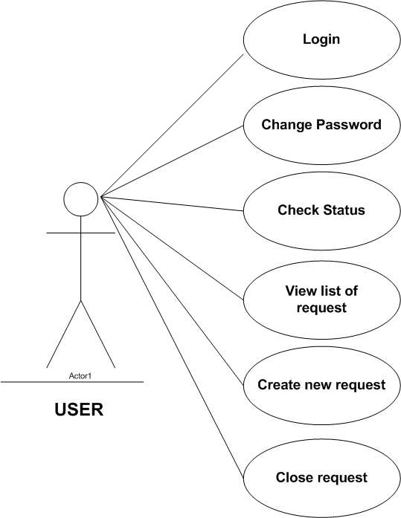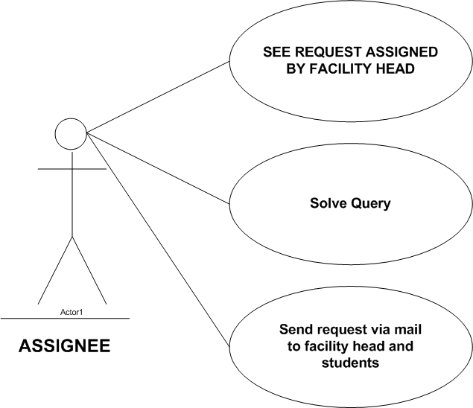

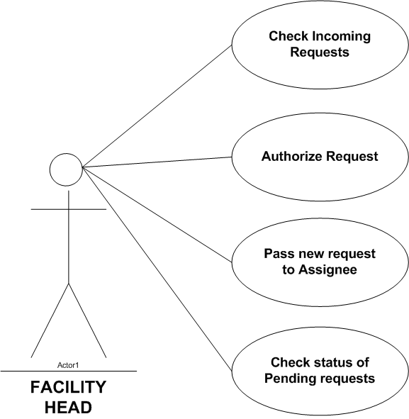

Activity Diagram

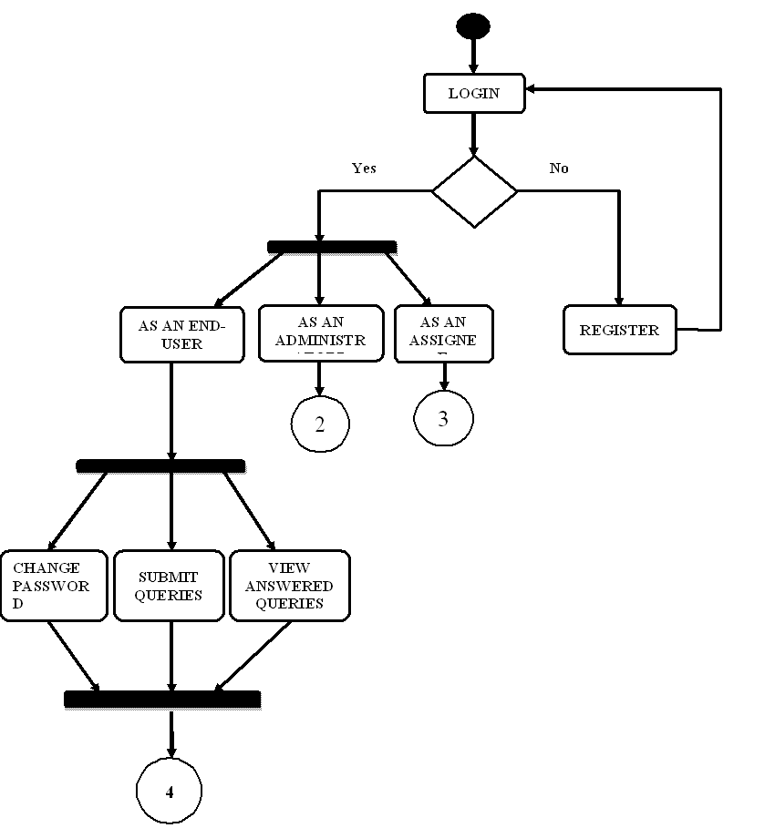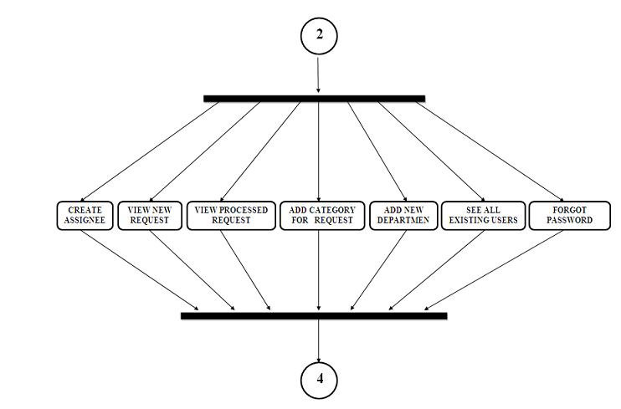An activity diagram is a behavioral diagram i.e. it depicts the behavior of a system. An activity diagram portrays the control flow from a start point to a finish point showing the various decision paths that exist while the activity is being executed.

**ERD Diagram**

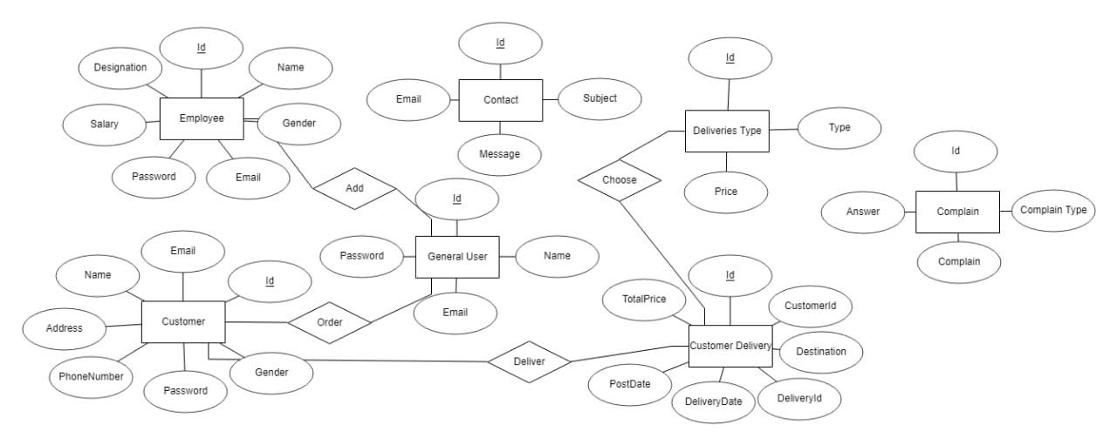An entity–relationship model describes interrelated things of interest in a specific domain of knowledge. A basic ER model is composed of entity types and specifies relationships that can exist between entities

Testing

#### INTRODUCTION TO SYSTEM TESTING:

The purpose of testing is to discover errors. Testing is the process of trying to discover every conceivable fault or weakness in a work product. It provides a way to check the functionality of components, sub-assemblies, assemblies and/or a finished product It is the process of exercising software with the intent of ensuring that the Software system meets its requirements and user expectations and does not fail in an unacceptable manner. There are various types of test. Each test type addresses a specific testing requirement.

#### TYPES OF TESTING:

##### Unit testing:

Unit testing involves the design of test cases that validate that the internal program logic is functioning properly, and that program inputs produce valid outputs. All decision branches and internal code flow should be validated. It is the testing of individual software units of the application .it is done after the completion of an individual unit before integration. This is a structural testing, that relies on knowledge of its construction and is invasive. Unit tests perform basic tests at component level and test a specific business process, application, and/or system configuration. Unit tests ensure that each unique path of a business process performs accurately to the documented specifications and contains clearly defined inputs and expected results.

#### Integration testing:

Integration tests are designed to test integrated software components to determine if they actually run as one program. Testing is event driven and is more concerned with the basic outcome of screens or fields. Integration tests demonstrate that although the components were individually satisfaction, as shown by successfully unit testing, the combination of components is correct and consistent. Integration testing is specifically aimed at exposing the problems that arise from the combination of components.

##### Functional test:

Functional tests provide systematic demonstrations that functions tested are available as specified by the business and technical requirements, system documentation, and user manuals.

Functional testing is centered on the following items:

Valid Input : identified classes of valid input must be accepted. Invalid Input : identified classes of invalid input must be rejected. Functions : identified functions must be exercised.

Output : identified classes of application outputs must be exercised. Systems/Procedures: interfacing systems or procedures must be invoked.

Organization and preparation of functional tests is focused on requirements, key functions, or special test cases. In addition, systematic coverage pertaining to identify Business process flows; data fields, predefined processes, and successive processes must be considered for testing. Before functional testing is complete, additional tests are identified and the effective value of current tests is determined.

##### System Test:

System testing ensures that the entire integrated software system meets requirements. It tests a configuration to ensure known and predictable results. An example of system testing is the configuration-oriented system integration test. System testing is based on process descriptions and flows, emphasizing pre-driven process links and integration points.

##### White Box Testing:

White Box Testing is a testing in which in which the software tester has knowledge of the inner workings, structure and language of the software, or at least its purpose. It is purpose. It is used to test areas that cannot be reached from a black box level.

#### Unit Testing:

Unit testing is usually conducted as part of a combined code and unit test phase of the software lifecycle, although it is not uncommon for coding and unit testing to be conducted as two distinct phases.

#### Black Box Testing:

Black Box Testing is testing the software without any knowledge of the inner workings, structure or language of the module being tested. Black box tests, as most other kinds of tests, must be written from a definitive source document, such as specification or requirements document, such as specification or requirements document. It is a testing in which the software under test is treated, as a black box. you cannot “see” into it. The test provides inputs and responds to outputs without considering how the software works.

##### Test strategy and approach

Field testing will be performed manually and functional tests will be written in detail.

#### Test objectives

* All field entries must work properly.
* Pages must be activated from the identified link.
* The entry screen, messages and responses must not be delayed.

#### Features to be tested

* Verify that the entries are of the correct format
* No duplicate entries should be allowed
* All links should take the user to the correct page.

#### Integration Testing:

Software integration testing is the incremental integration testing of two or more integrated software components on a single platform to produce failures caused by interface defects.

The task of the integration test is to check that components or software applications, e.g. components in a software system or – one step up – software applications at the company level – interact without error.

#### Test Results:

All the test cases mentioned above passed successfully. No defects encountered.

Screenshots

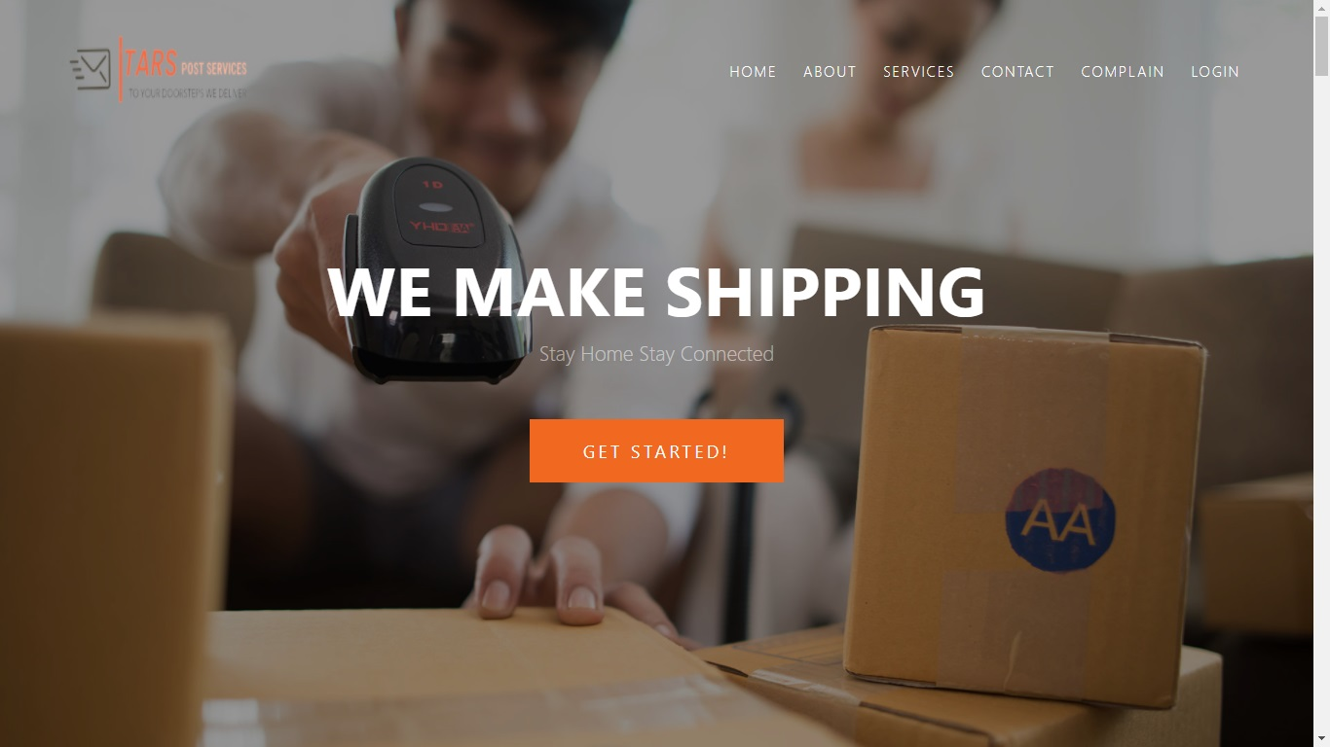Home Page

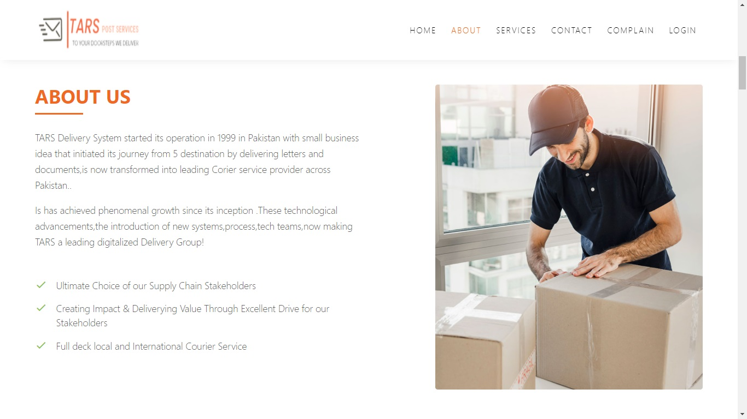**About Us**

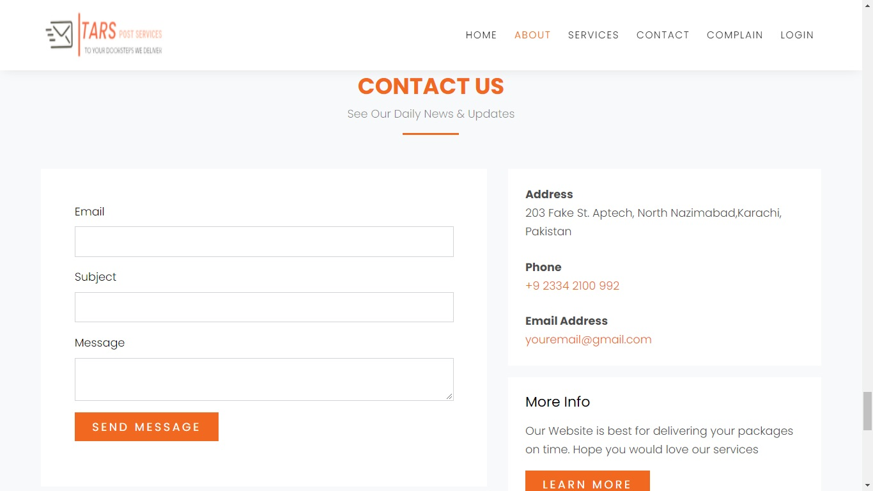**Contact Us**

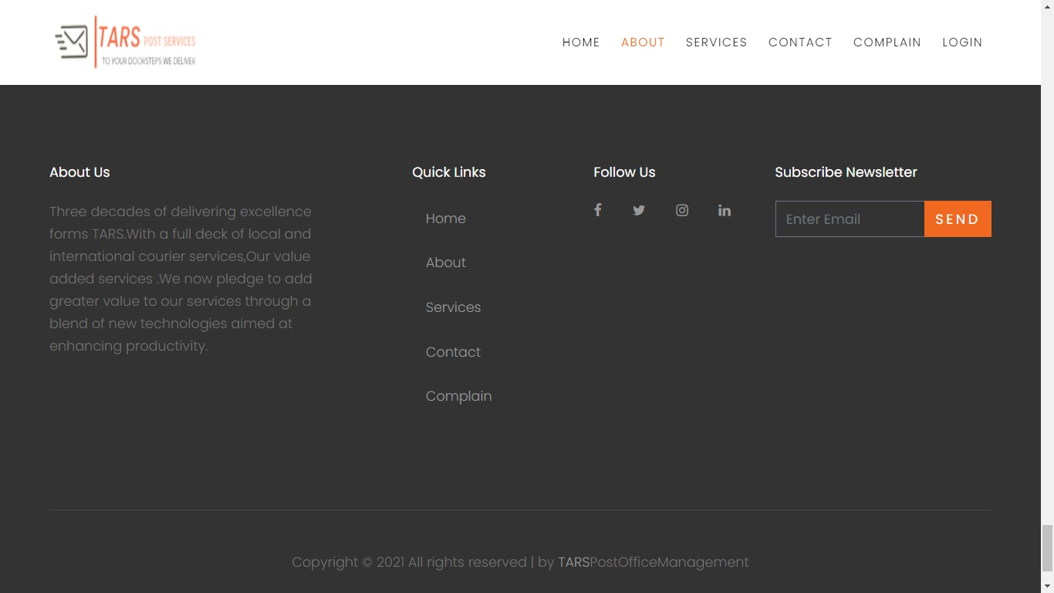**Footer Navbar**

**Our Services**

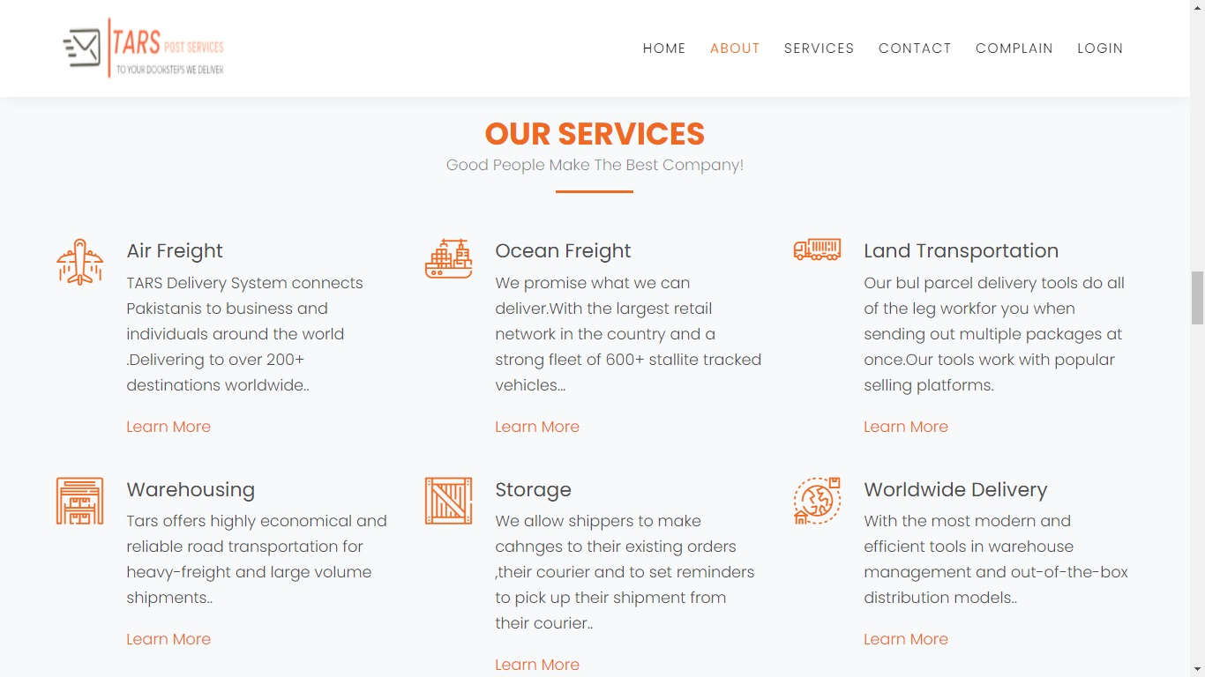

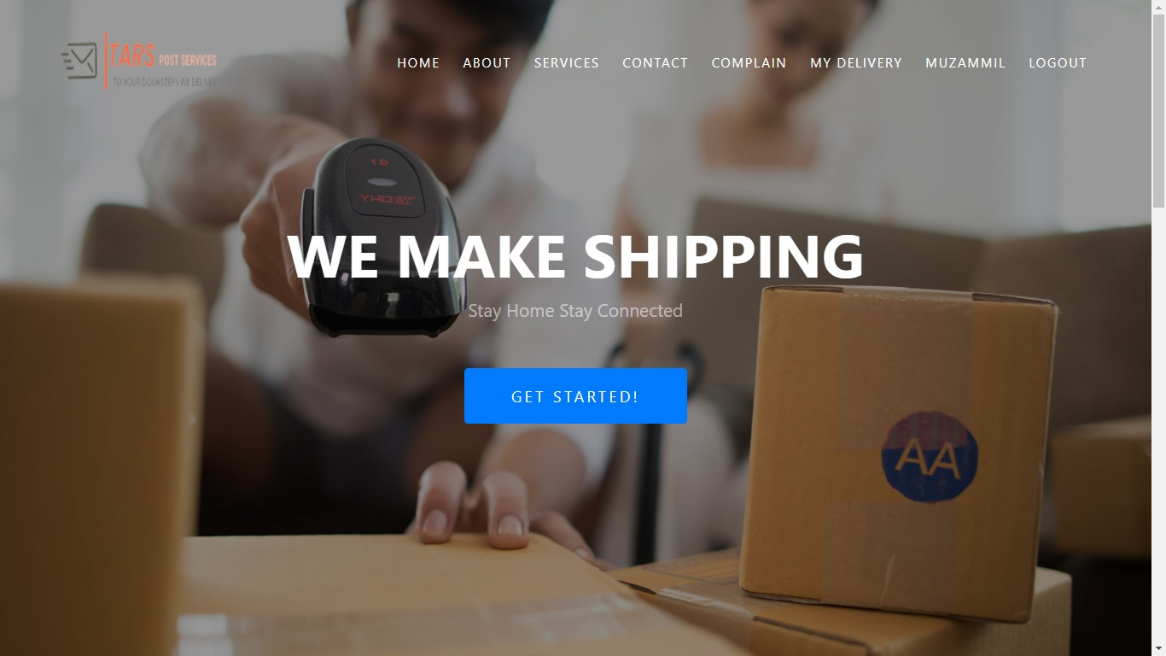**Admins View**